File permissions in Linux

Project description
In this activity, I worked on managing Linux file and directory permissions for the /home/researcher2/projects directory. My goal was to check who had access to certain files, fix any incorrect permissions, and make sure everything followed proper security rules. This matters because authorization determines who can read, change, or run files, and it helps protect sensitive information from being modified by people who shouldn’t have access.

Check file and directory details
I navigated to the projects directory and listed all files, including hidden files. The directory contained the following files:
- project_k.txt
- project_m.txt
- project_r.txt
- project_t.txt
- .project_x.txt (hidden)
There was also one subdirectory: drafts.
All files and the directory were owned by the research_team group.
.project_x.txt was the hidden file inside the directory.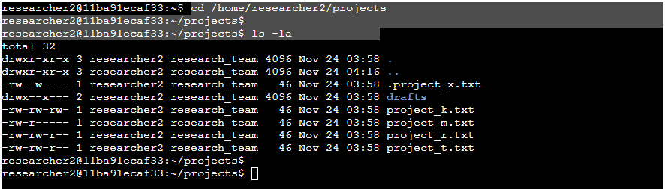

Describe the permissions string
I went into the projects directory and listed all the files, including the hidden ones. The directory contained:
- project_k.txt
project_m.txt
- project_r.txt
- project_t.txt
- .project_x.txt (hidden)
There was also one subdirectory called drafts.
All the files and the directory were owned by the research_team group, and the hidden file was just another file inside that same directory.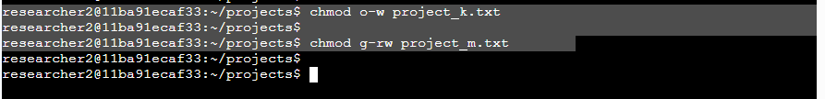
Understanding the Permissions String
Linux shows permissions as a 10-character string.
Example: -rw-rw-r--
- 1st character: file type (d for directory, - for file)
- 2nd–4th: user permissions
- 5th–7th: group permissions
- 8th–10th: other (everyone else) permissions
These characters determine who can view, edit, or execute a file.

Change file permissions
I checked for incorrect permissions.
- project_k.txt allows write access to others, which is not allowed.
I removed that with:
chmod o-w project_k.txt

Change file permissions on a hidden file
Next, I checked project_m.txt. It is supposed to be restricted so only the user should have read/write access.
The group currently had read permission, so I removed group access using:
chmod g-rw project_m.txt



Change directory permissions
The hidden file .project_x.txt should only be readable by the user and the group — no writing allowed.
The group had incorrect write permissions.
I updated the file so both user and group can only read it:
chmod ug=r .project_x.txt

Summary
In this lab, I:
- Reviewed all files and permissions in the projects directory
- Found several incorrect permissions
- Used chmod to remove unauthorized access
- Updated permissions on a hidden file
- Restricted directory access to the intended user
These changes helped secure the files and ensured that everything followed proper authorization practices on the Linux system.

